**Assembly instructions document**

This document serves as the assembly instructions for a four channel differential input 10X probe adapter board for the XIAO SAMD21 module. The adapter board scales the 0 to 3.3 V input range of the XIAO module by 10X and provides a means to offset the range to provide negative input voltages. +/- 16 V differential input is the nominal configuration.

These instructions do not teach the reader how to solder through-hole printed circuit boards. We could reproduce a soldering tutorial here but seriously, there are so many good ones out there already, it's probably a waste of time. If the reader has little experience soldering then the following tutorials from SparkFun may be useful:

https://www.sparkfun.com/tutorials/106

https://learn.sparkfun.com/tutorials/how-to-solder-through-hole-soldering

Other such soldering tutorials may be found on line as well.

**Bill of Materials:**

|  |  |  |  |
| --- | --- | --- | --- |
| Item | Qty | Reference(s) | Value |
| 1 | 2 | J1, J2 | 01x06 Female Header Pin |
| 2 | 2 | J3, J4 | 01x07 Female Header Pin |
| 3 | 1 | J5, J6 | XIAO SAMD21 Board |
| 4 | 8 | R1, R2, R3, R4, R5, R6, R7, R8 | 1Meg (1/8W) |
| 5 | 8 | R9, R10, R11, R12, R13, R14, R15, R16 | 100k (1/8W) |
| 6 | 2 | R17, R18 | 100 (1/8W) |
| 7 | 4 | R19, R20, R21, R22 | 220 (1/8W) |
| 8 | 4 | R23, R24, R25, R26 | 510 (1/8W) |
| 9 | 1 | RV1 | 500 (optional) |
| 10 | 1 | U1 | LM324 or LM2902 or MCP6004 |

Amplifier U1 uses the standard pinout for quad op-amps and any version that can operate from a 4.7 V power supply could potentially be used. Rail-Rail input / output capable amplifiers are best suited for this application. Low cost quad devices such as the LM324 or similar can be used because it supports an input common mode voltage that includes ground. Depending on the particular version / vendor of the LM324, pull down resistors R23 – R26 (510 ohm) may or may not be needed. If a true Rail-Rail amplifier such as the MCP6004 is used resistors R23, R24, R25, R26 can be omitted.

It is best to start assembly with the components with the lowest profile, like the resistors. Place all the resistors of the same value at a time and solder them in place before moving on to the next value. Locate where each resistor goes by the reference designator (R1, R2 etc.) on the silk screen (Note: figure 2.) A small piece of masking tape can be used to hold the resistors tight to the top surface of the board while soldering the leads on the bottom of the board. Once all the resistors are installed move on to the next highest profile components like the DIP op-amp. Be sure to note the notch in the silk screen outline for the op-amp and Pin 1 designated by the square solder pad. Be sure to insert the op-amp properly aligned with Pin 1.

The XIAO SAMD21 board is installed using the J5 and J6 locations with the USB C connector facing outward toward the PCB board edge (Note: figure 3 assembled PCB).

The female header sockets are the tallest and should be installed last.

The offset adjustment pot, RV1, is optional. If a 250 Ω pot is used you should increase R17, R18 to 220 Ω or even leave them off for a lower value RV1.

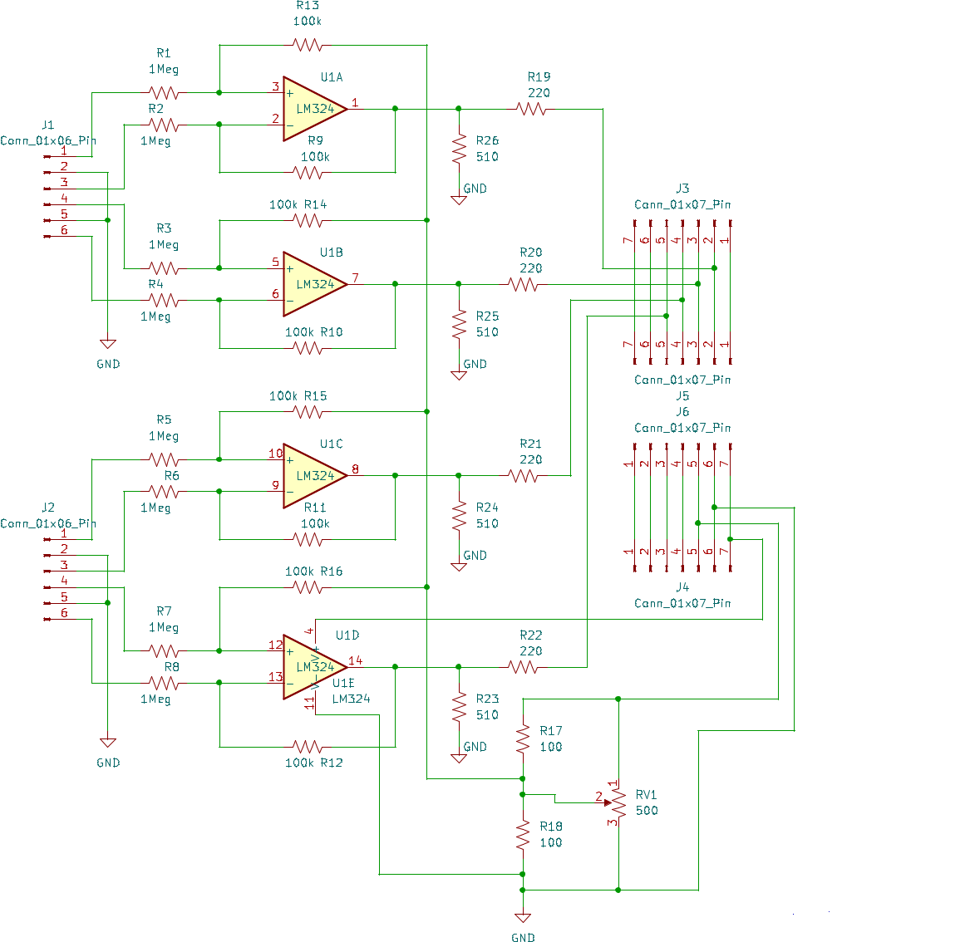

Figure 1 XIAO SAMD21 10X probe schematic

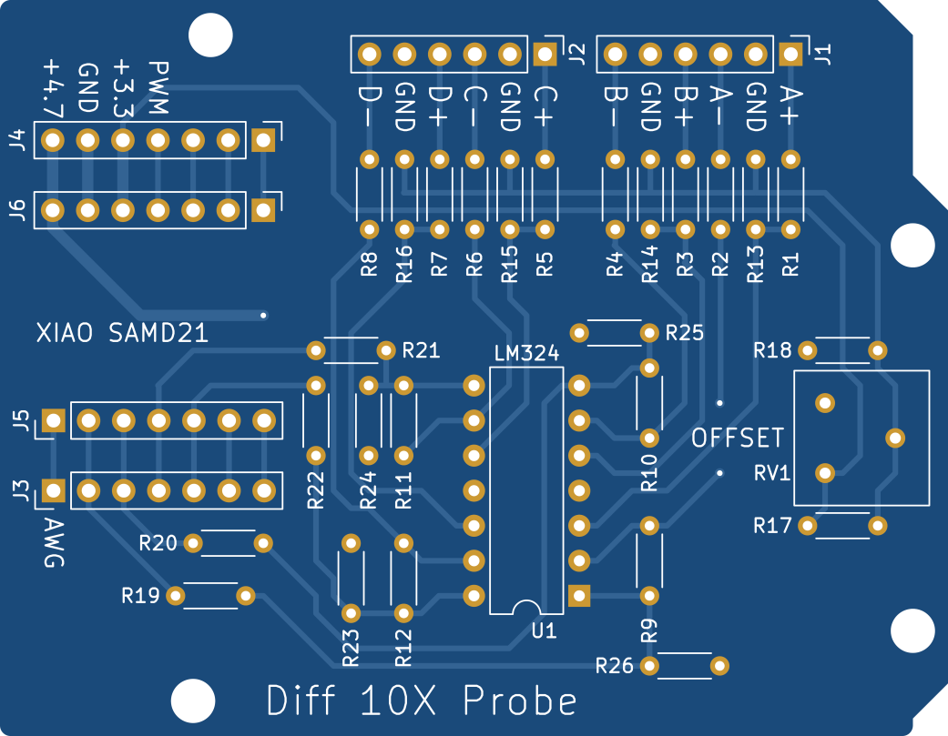

Figure 2 XIAO SAMD21 10X probe PCB Top - silk screen

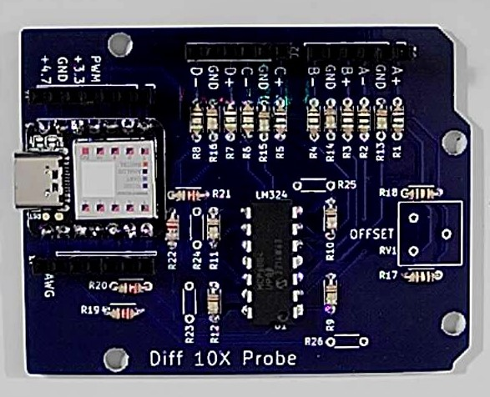

Figure 3 XIAO SAMD21 10X probe PCB assembled (MCP6004).

**Resistor Color Code:**

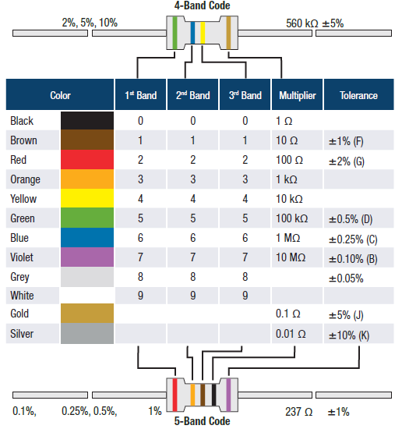

**Soldering Hints:**

1. Insert the component tight against the PCB surface and carefully solder the leads.

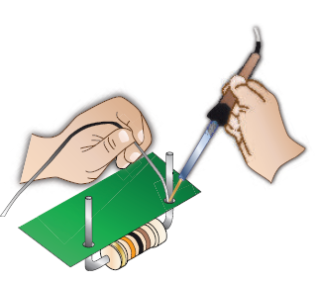

2. Make sure the solder joints completely surround the component lead and are cone-shaped and shiny.

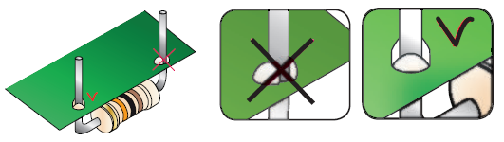

3. Trim excess leads as close as possible to the solder joint.

